DIAGRAMS OF SMART TRIP PLANNER

- USECASE DIAGRAM:

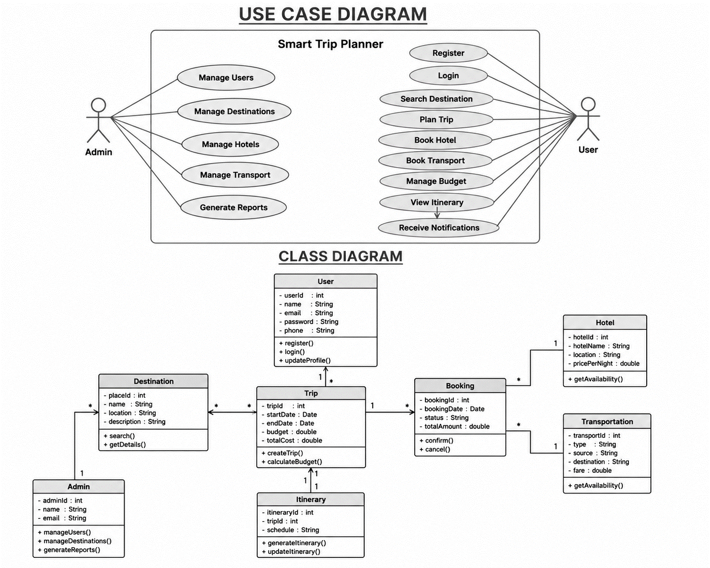

- CLASS DIAGRAM:

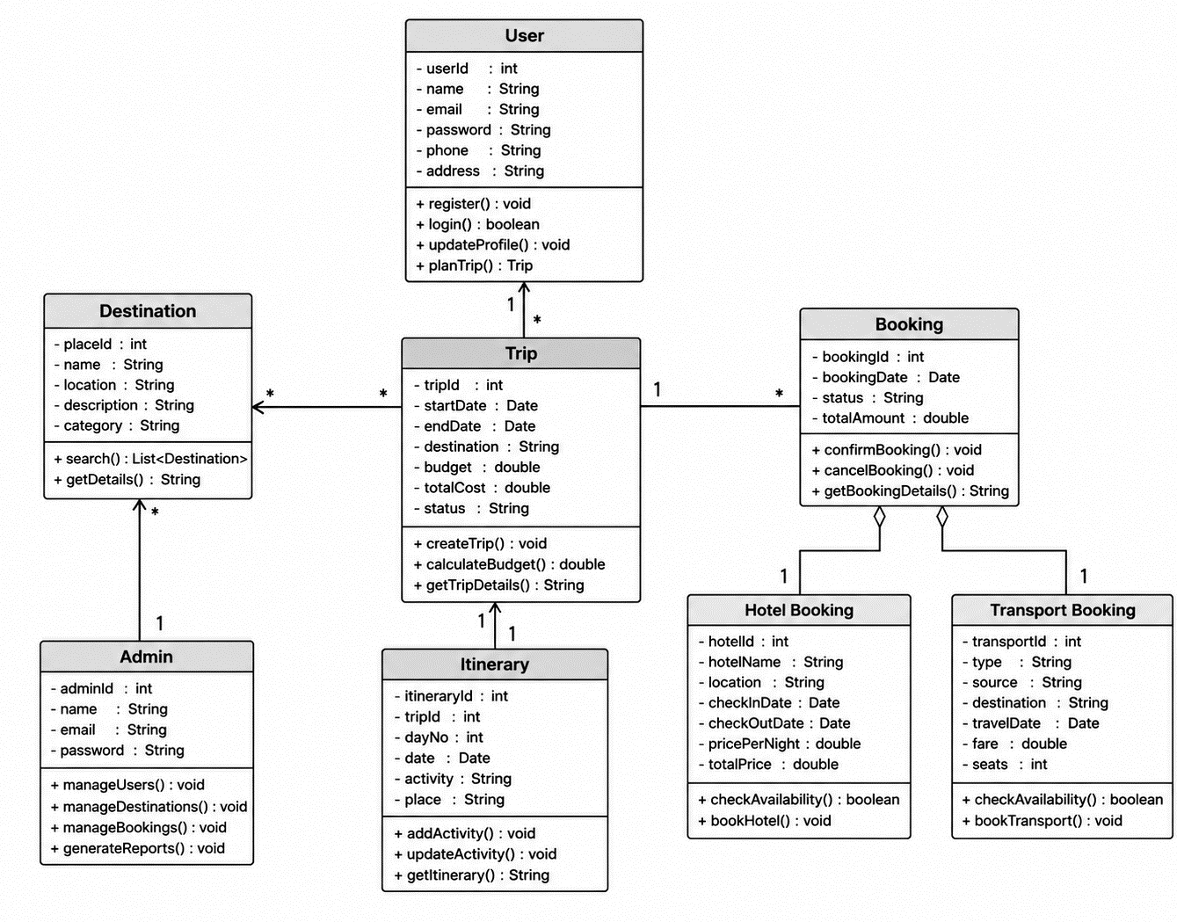

- SEQUENCE DIAGRAM:

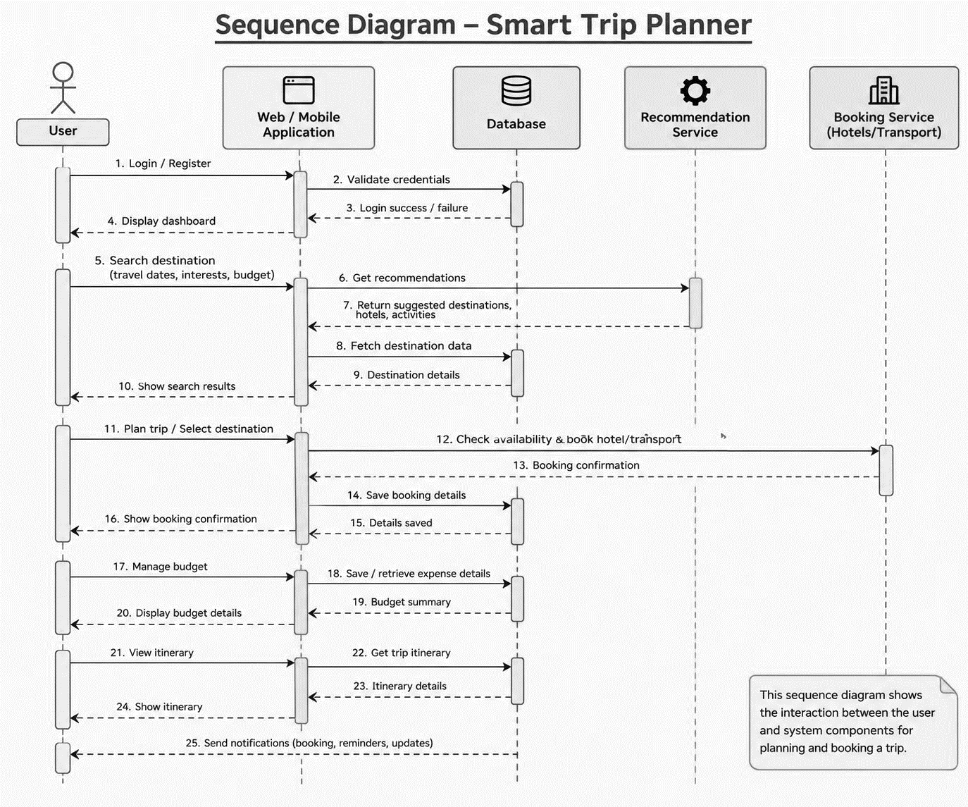

- STATE DIAGRAM:

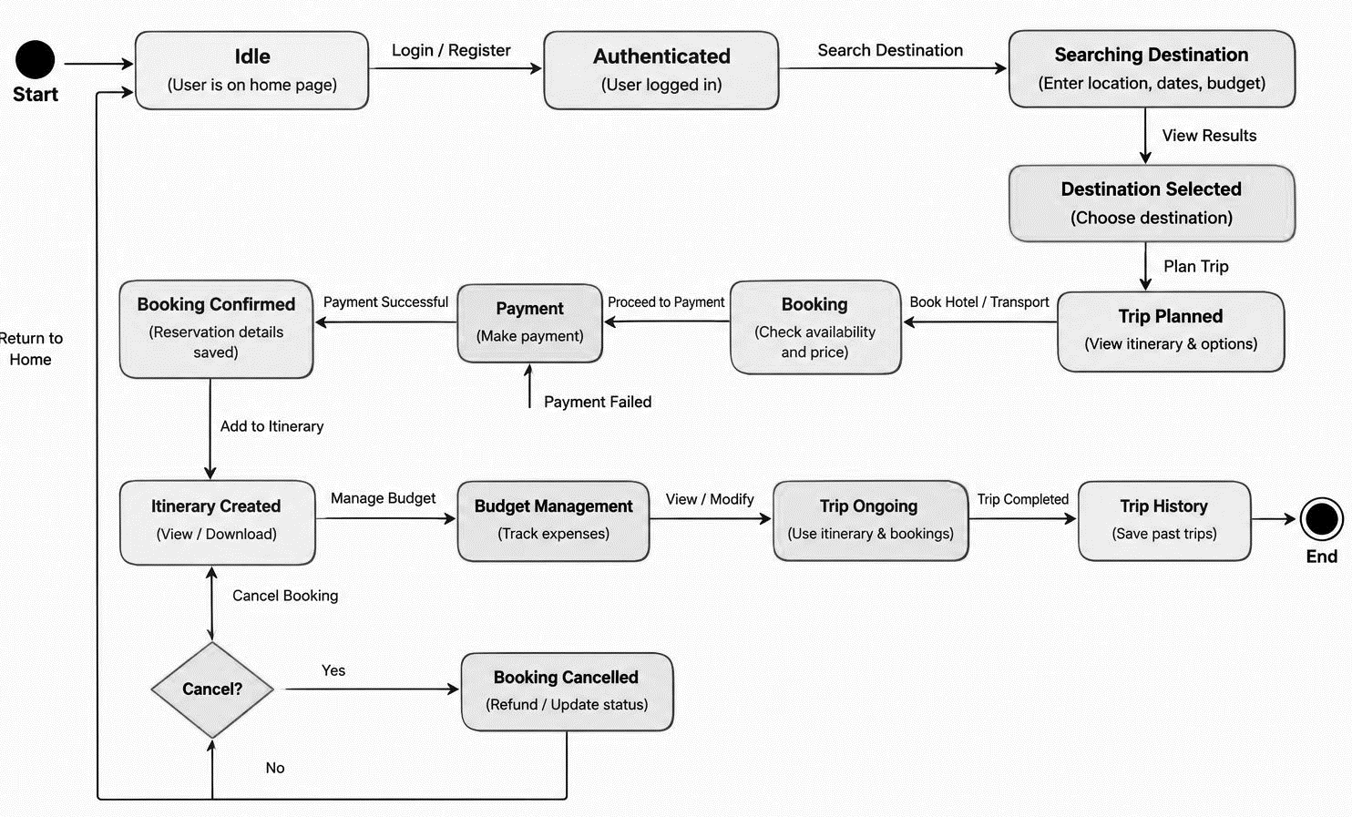

- ACTIVITY DIAGRAM:

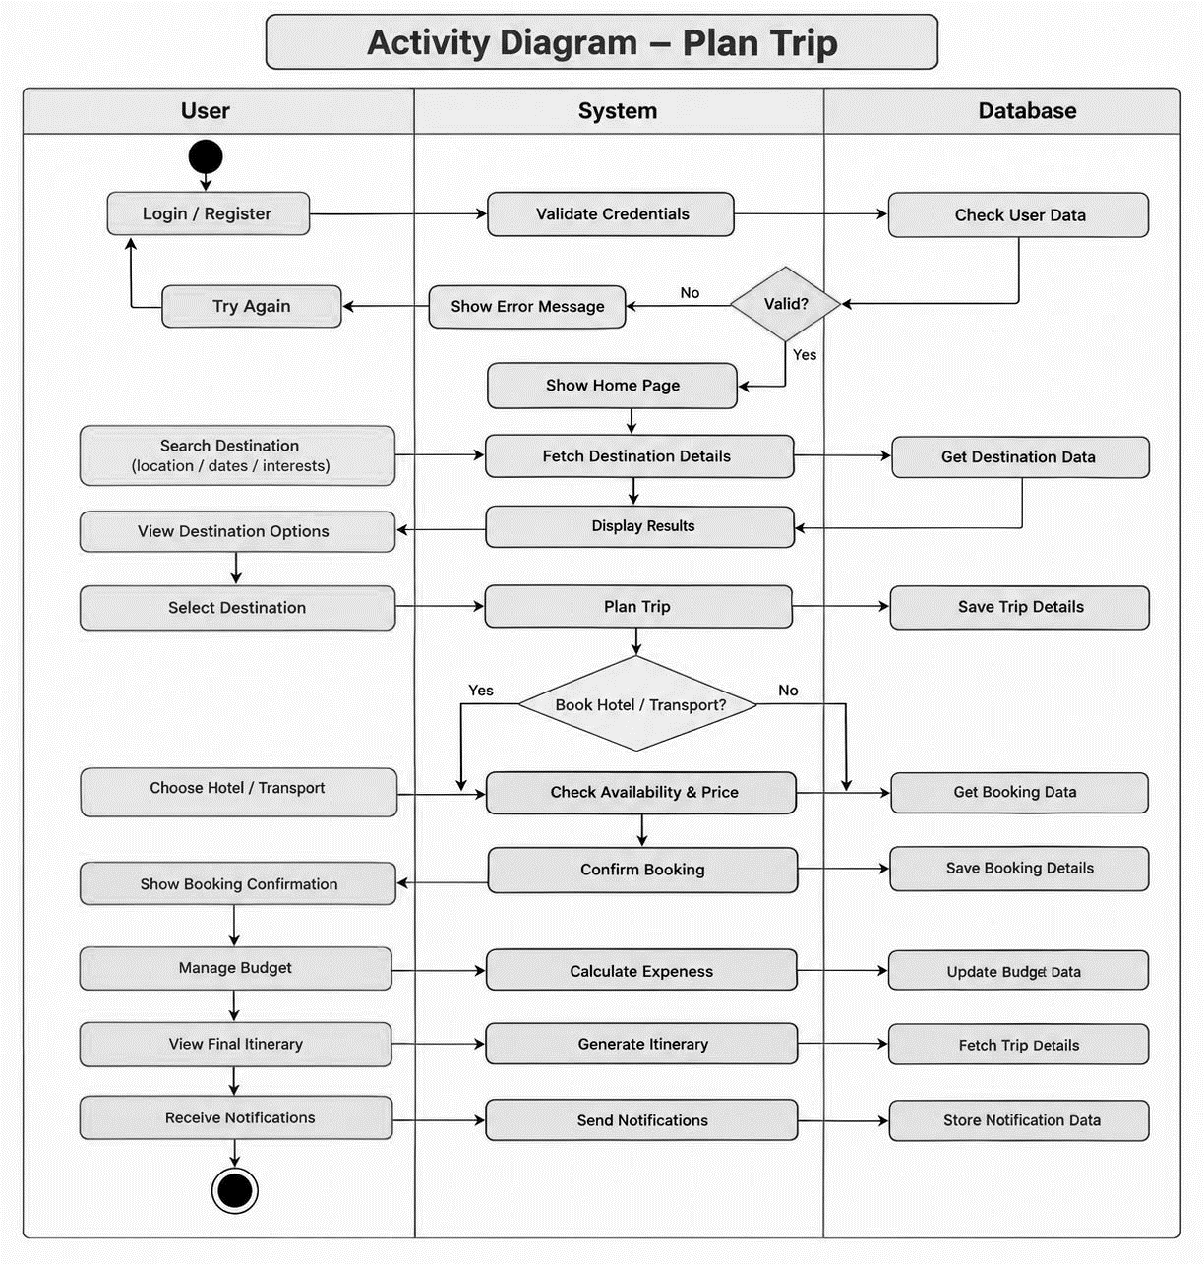
- COLLABORATION DIAGRAM:

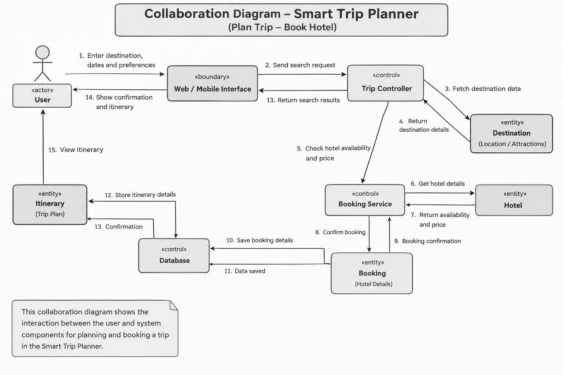

- COMPONENT DIAGRAM:

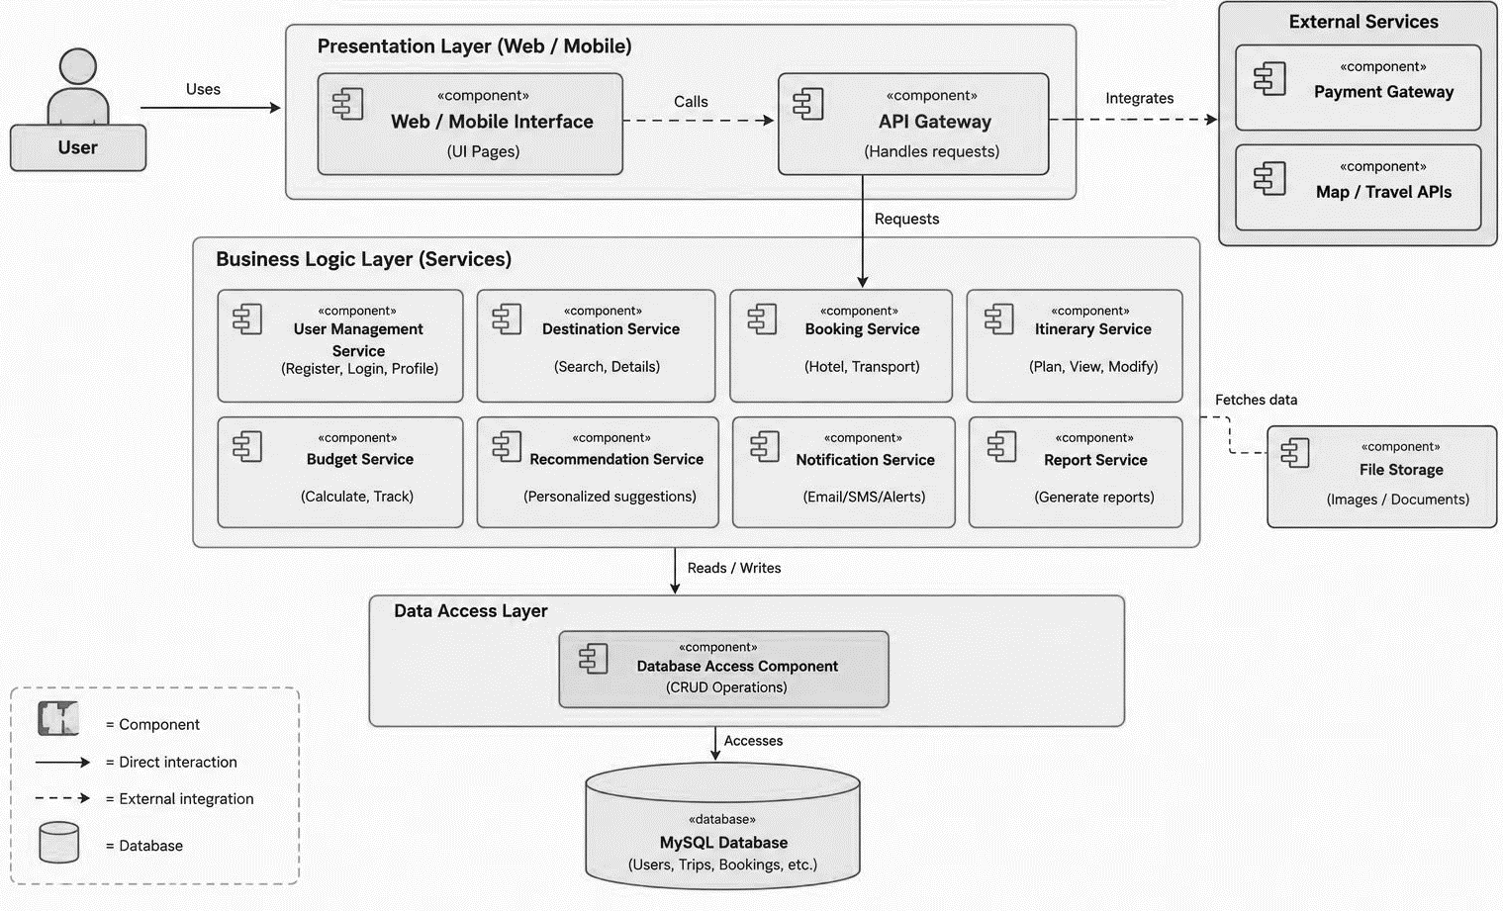

- PACKAGE DIAGRAM:
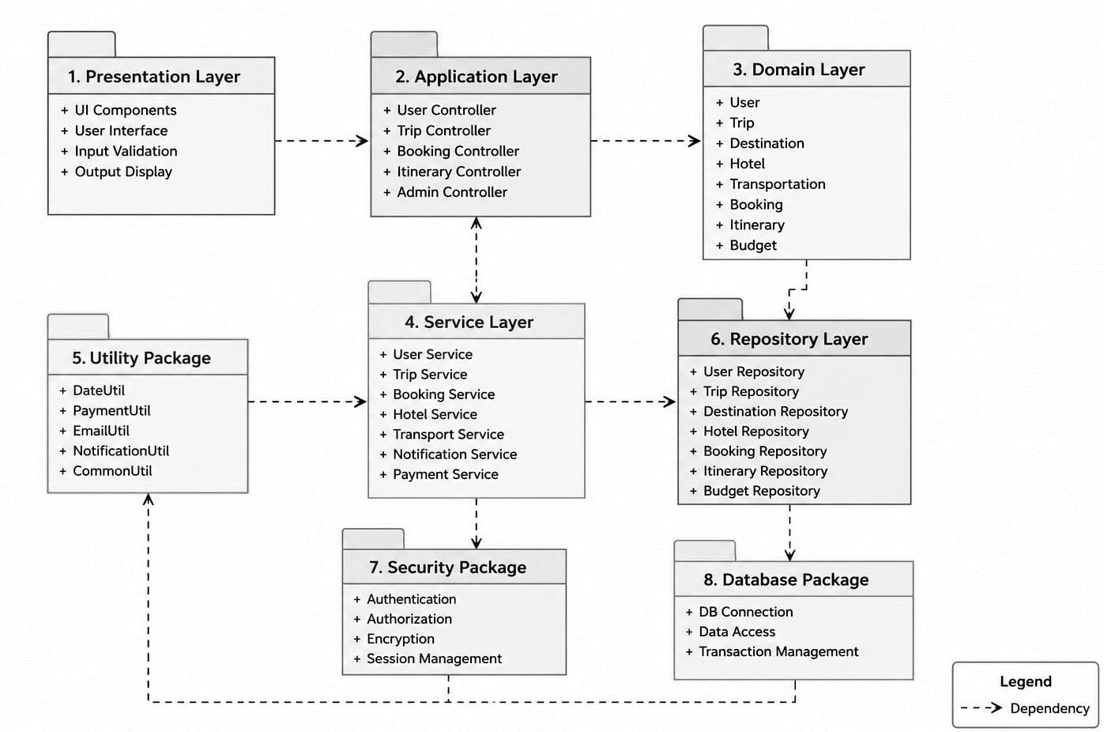

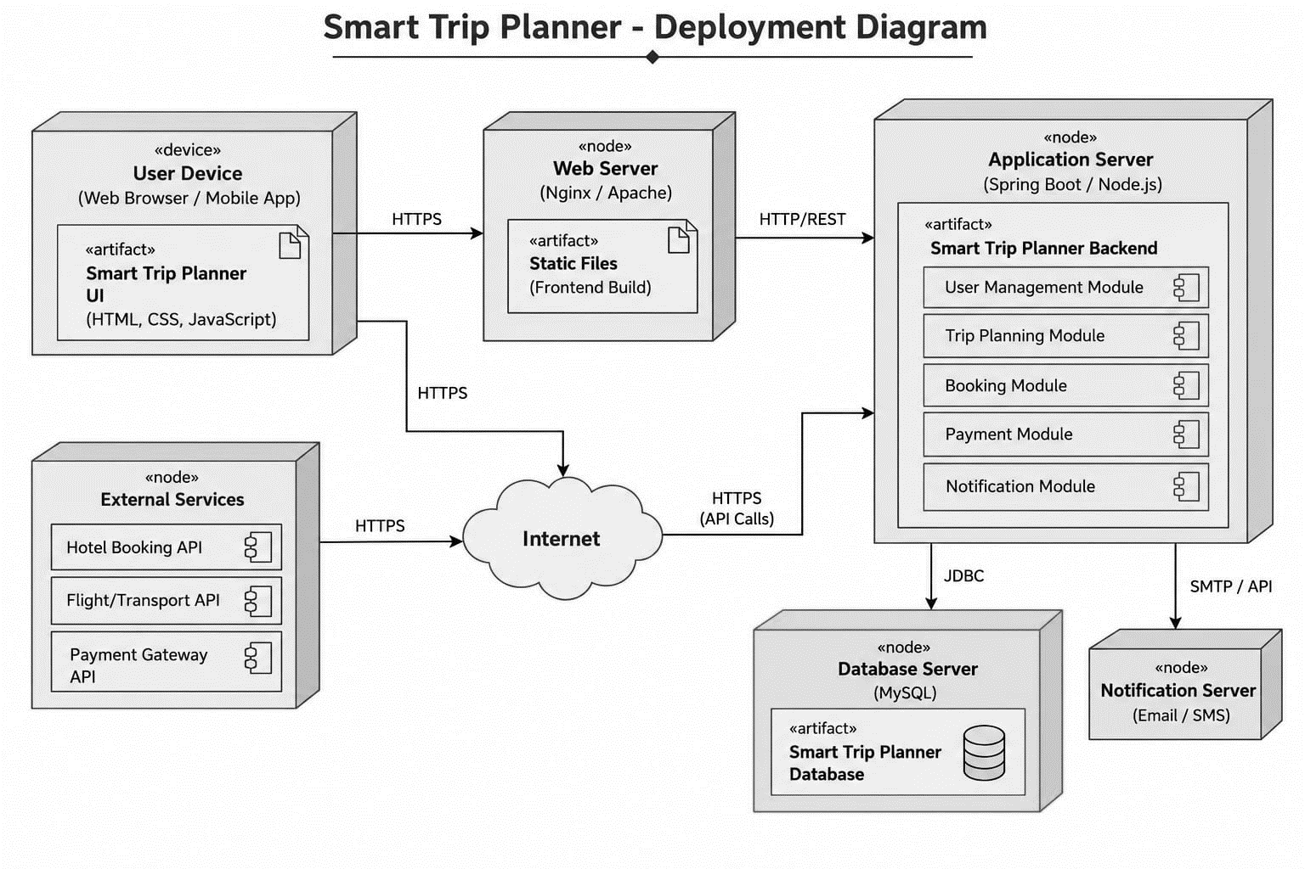
- DEPLOYMENT DIAGRAM:

